# ALT KEYS

For ease of access alt keys and alt tags have been added throughout Oval Ski Clubs website.

The alt keys run through every page of the website and they allow for easy navigation throughout the website and can be used via the following method:

* Alt + H = Home page
* Alt + A = About Us Page
* Alt + C = Contact Us Page
* Alt + F = FAQ’s Page
* Alt + S = Social Events Page
* Alt + R = Racing Team Page
* Alt + L = Lessons Page

The access keys have been added to every page by adding some simple coding.

<li><a href="index.html" title="Home" accesskey="h">Home</a></li>

<!-- first drop down box-->

<li class="dropdown">

<a href="#" title="Information"class="dropdown-toggle" data-toggle="dropdown">Information <b class="caret"></b></a>

<!--Information drop down-->

<ul class="dropdown-menu">

<li><a href="AboutUs.html" title="About Us" accesskey="a">About Us</a></li>

<li class="active"><a href="ContactUs.html"title="Contact Us" accesskey="c">Contact Us</a></li>

<li><a href="FAQ.html"title="Frequently Asked Questions" accesskey="Q">FAQ's</a></li>

</ul>

By adding the accesskey=”” it was simple to add an access key to any link on each page. For each page I have used the first letter of that page as the access key as can be seen above. The About Us page is A and the Contact Us page is C etc…. The only page that is an exception to this is the FAQ’s page as can be seen above. This was put as a ‘q’ because when using f the settings page was opened on most browsers.

This has been checked to be working on every page allowing users easy navigation throughout the website.

# Alt Tags

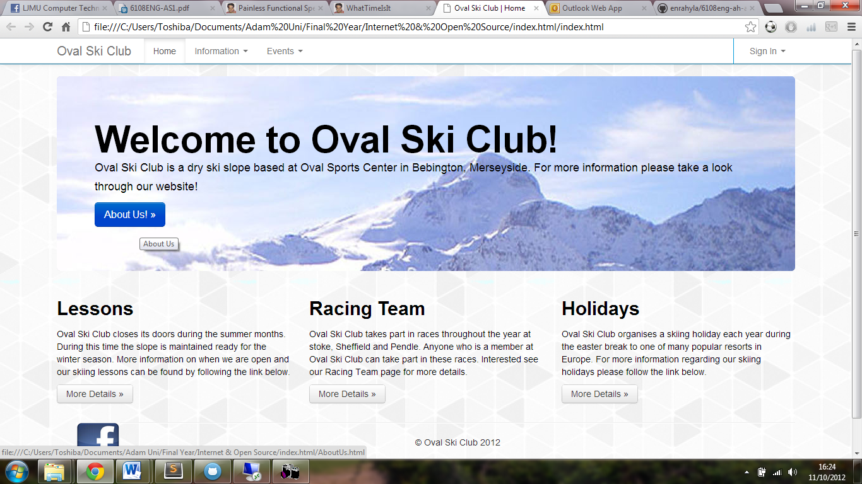Alt tags have been added throughout the website to images, buttons, email links, drop down boxes etc. This has been implemented on every page for visually impaired users of the website. When hovering the mouse over an object for a period of time eventually an alt tag will appear as can be seen below.



The alt tag will tell the user what the button or the link says or does. For this example the button reads About Us and so does the Alt Tag.

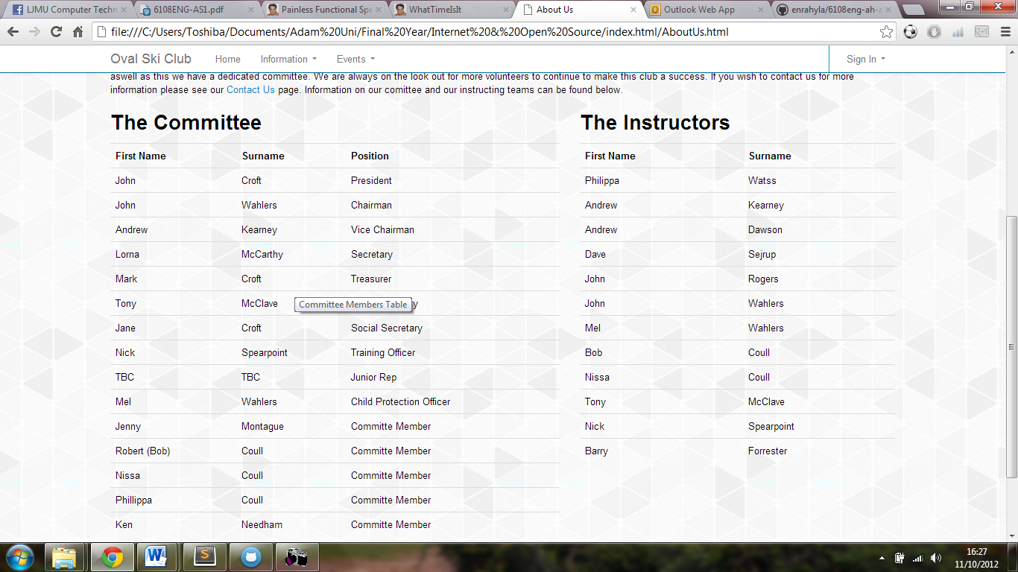This has also been done on tables as can be seen below:

This alt tag tells the users what the table is. It reads ‘Committee Members Table’

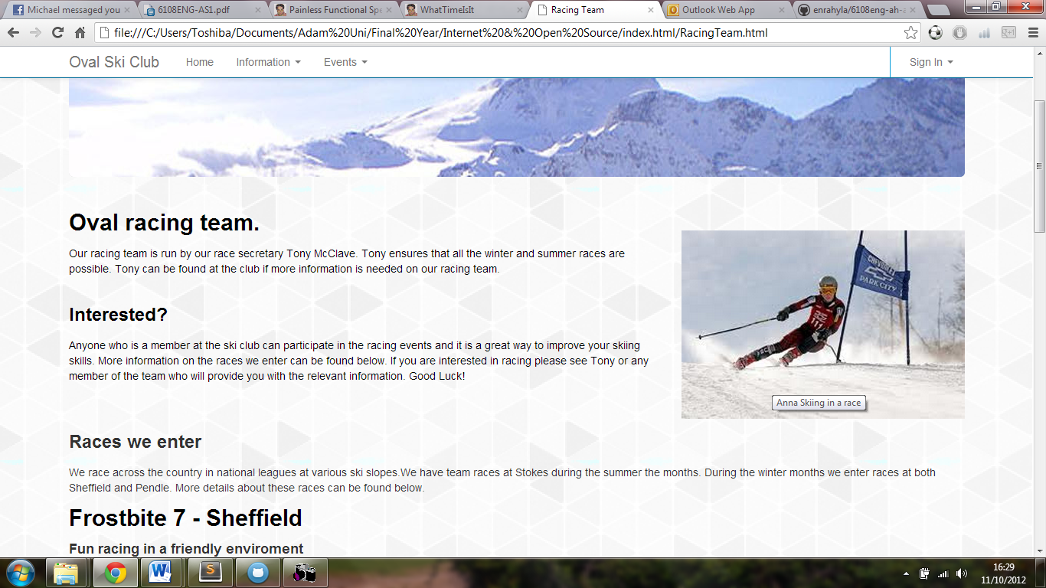Alt tags have been added to images to tell the user what the images are as can be seen below:

The alt text on the image describes what the image is, in this instance the image shows ‘Anna skiing in a race’.

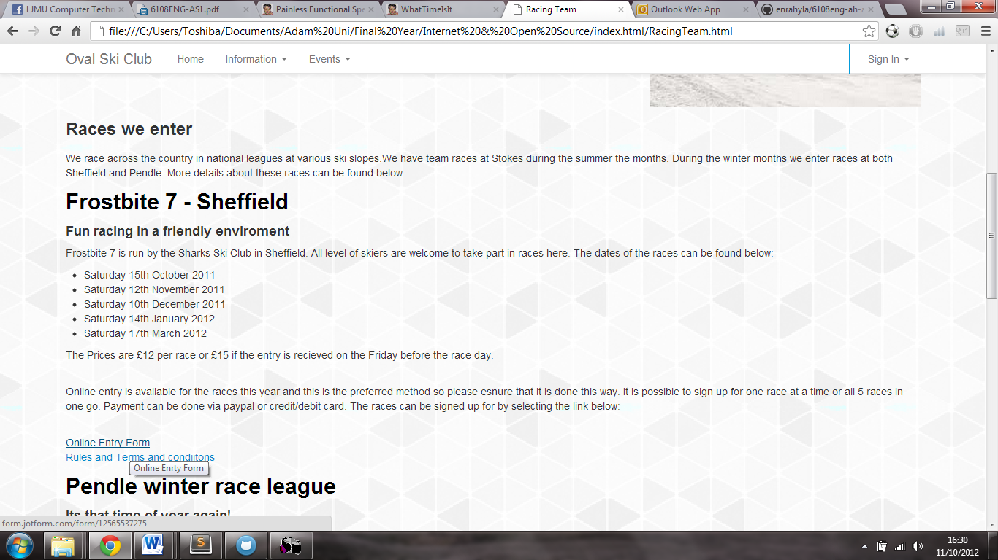Alt tags have also been added to links to let users no what they are. As can be seen below:

This Alt Tag informs the user that the link will open and Online Entry Form as can be seen in the image.

The alt text is added to object throughout the website by adding some simple text. It has been added to:

* Buttons

<button <input class= "btn btn-primary" name="commit" value="Sign In" title="Sign In">Sign In</button>

* Dropdown menus

<a href="#" class="dropdown-toggle" data-toggle="dropdown" title="Events">Events <b class="caret"></b></a>

* Images

<img src="assets/img/skirace.jpg" alt height="500px" width="500px" title="Anna Skiing in a race">

* Links

<a href="http://form.jotform.com/form/12565537275" title="Online Enrty Form">Online Entry Form</a>

<li><a href="Social.html" title="Social Events" accesskey="s">Social</a></li>

* Tables

<div class="container"><!--start of container-->

<div class="row">

<div class="span7">

<table class="table" <title="Committee Members Table">

Alt tags have been added to as many objects as possible throughout the website by simply adding title=”” to objects such as the examples given above. The allows for easier access for users throughout the website.